Question 1
Construct a concept map linking DBMS, Schema, Instance, Data Model, ER Diagram, Entity, Attribute, Relationship.
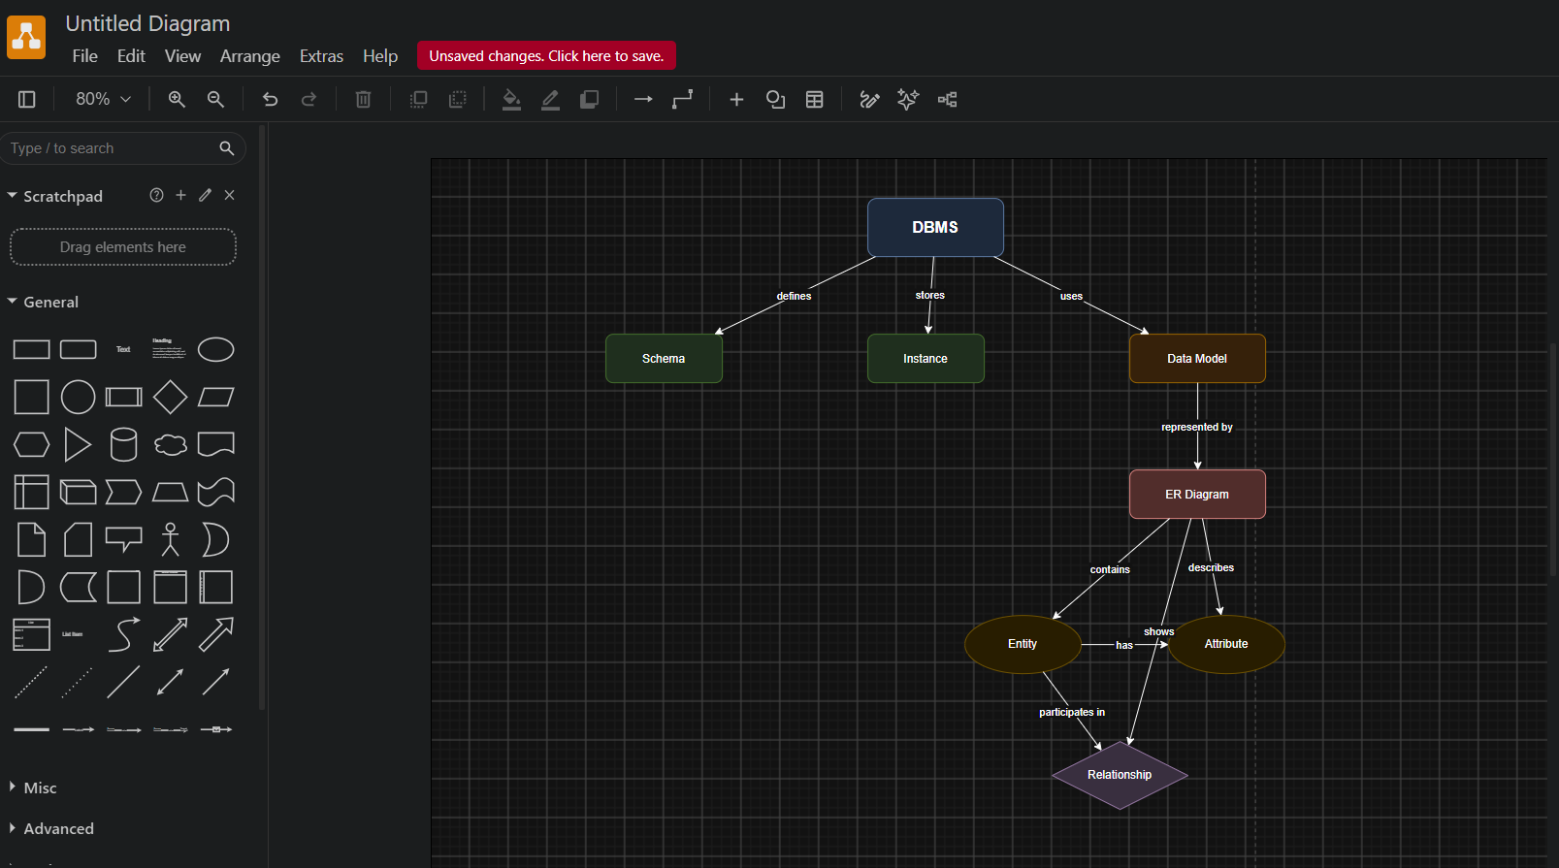
DBMS (Database Management System)
- A DBMS is software used to create, store, retrieve, update, and manage data efficiently.
- It acts as an interface between users and the database.
- Examples include MySQL, Oracle, SQL Server, and PostgreSQL.
Schema
- A schema is the logical blueprint or structure of a database.
- It defines tables, columns, relationships, and constraints.
- The schema changes very rarely.
Instance
- An instance is the actual data stored in the database at a particular moment.
- The instance changes whenever records are inserted, updated, or deleted.
Data Model
- A data model defines how data is organized, stored, and related.
- Common data models are Hierarchical, Network, Relational, and Object-Oriented.
ER Diagram
- An Entity-Relationship (ER) Diagram is a graphical representation of database design.
- It shows entities, attributes, and relationships.
Entity
- An entity is any real-world object about which data is stored.
- Example: Student, Employee, Book.
Attribute
- Attributes describe the properties of an entity.
- Example: Student ID, Name, Age.
Relationship
- A relationship represents the association between two or more entities.
- Example: Student enrolls in Course.
Conclusion
All these concepts work together to help a DBMS organize and manage data effectively.
Question 2
ANSI/SPARC Three-Level Architecture
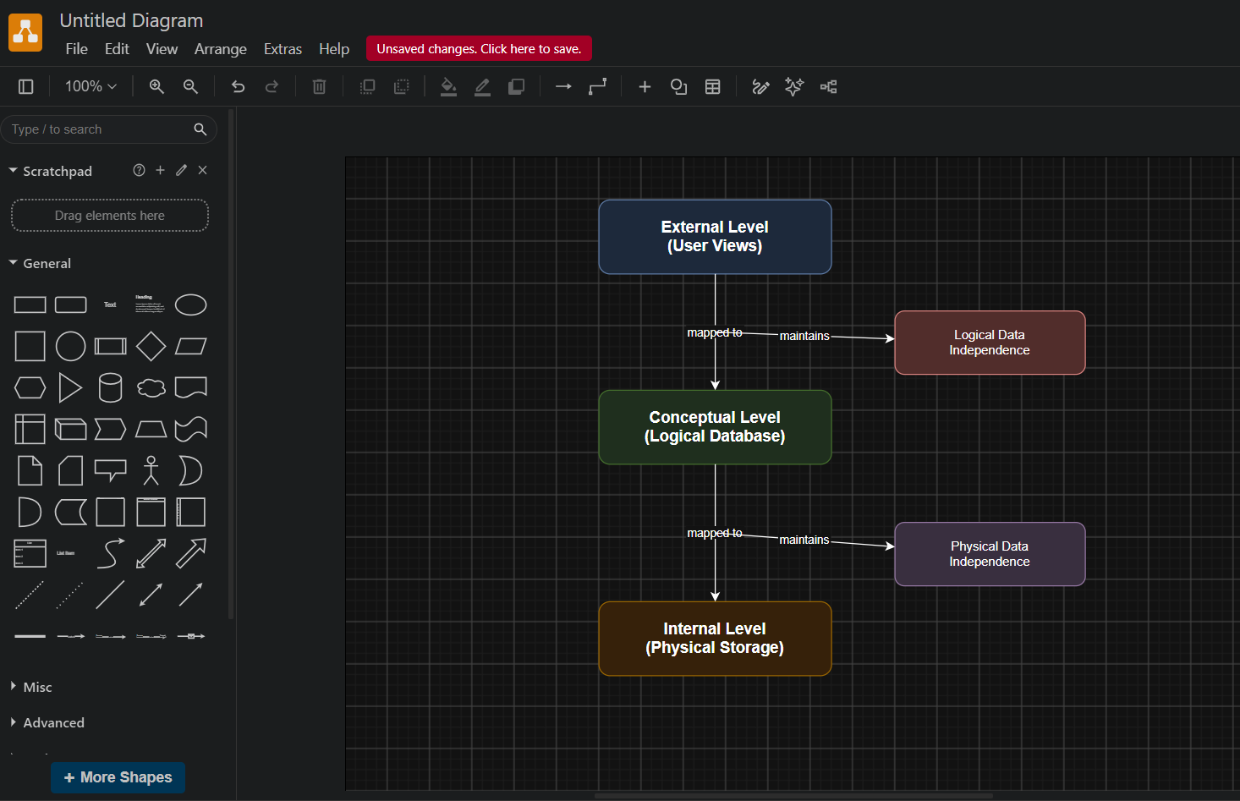

The ANSI/SPARC architecture divides the database into three levels.
External Level
- Represents the user's view of the database.
- Different users can have different views.
- Improves security by restricting unnecessary information.
Conceptual Level
- Describes the complete logical structure of the database.
- Contains entities, relationships, constraints, and data types.
- Independent of physical storage.
Internal Level
- Describes how data is physically stored.
- Includes indexing, file organization, and storage allocation.
Logical Data Independence
- Changes in the conceptual schema do not affect user views.
Physical Data Independence
- Changes in physical storage do not affect the conceptual schema.
Advantages
- Better security.
- Easier maintenance.
- Flexibility.
- Data independence.

Question 3

File-Based System vs Database System
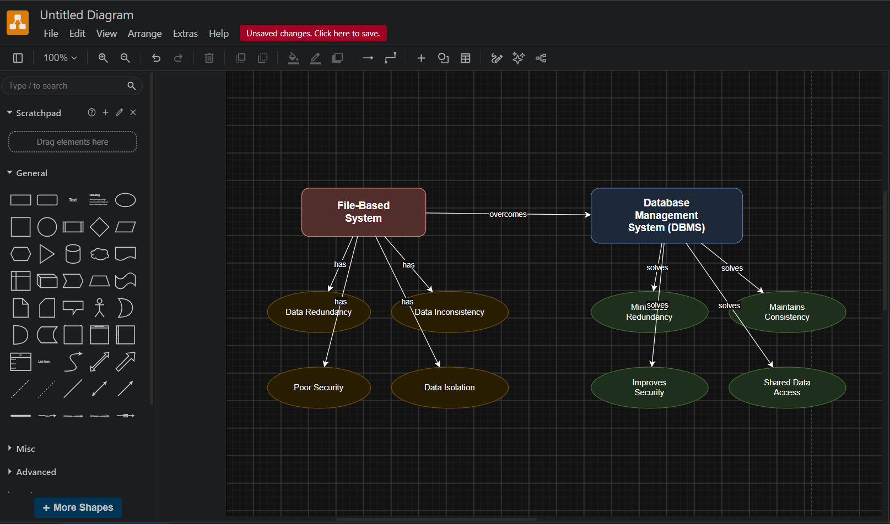
File-Based System
- Stores data in separate files.
- Difficult to maintain.
- High redundancy.
- Data inconsistency occurs frequently.
- Poor security.
- Difficult data sharing.
Database Management System
- Centralized storage.
- Reduces redundancy.
- Ensures consistency.
- Provides security.
- Supports backup and recovery.
- Allows multiple users simultaneously.
Problems Solved by DBMS
- Eliminates duplicate data.
- Maintains consistency.
- Improves security.
- Supports concurrent access.
- Provides backup and recovery.
Question 4

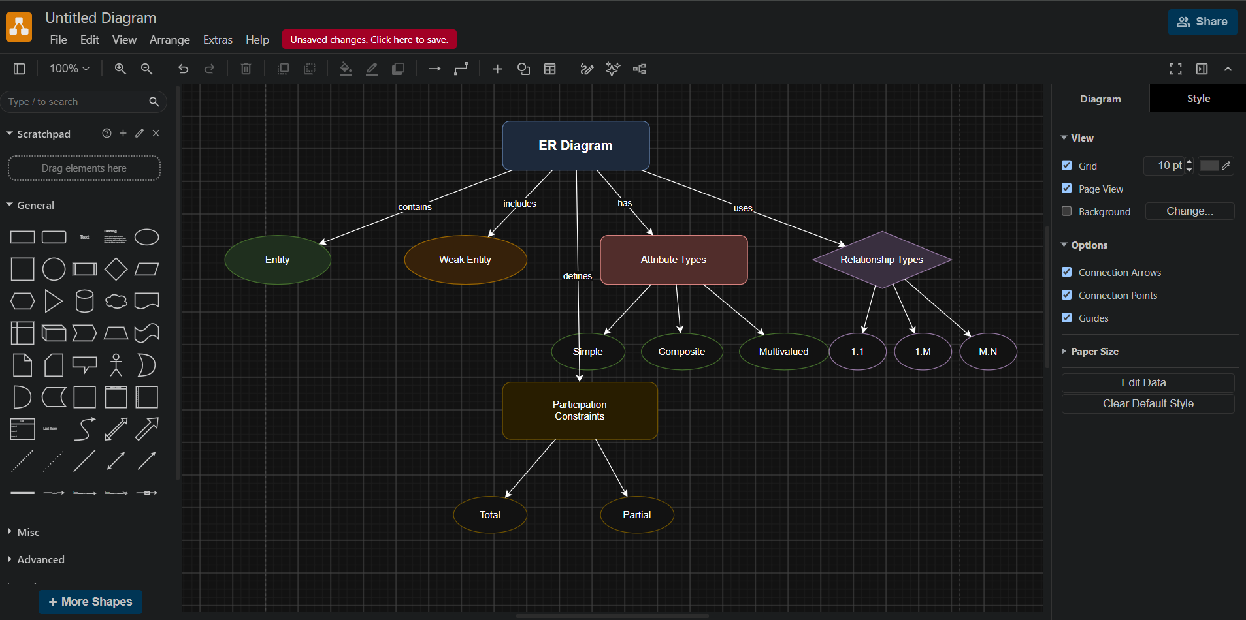
Entity
A real-world object.
Weak Entity
Depends on another entity for identification.
Attribute Types
- Simple Attribute
- Composite Attribute
- Single-Valued Attribute
- Multi-Valued Attribute
- Derived Attribute
Relationship Types
- One-to-One
- One-to-Many
- Many-to-One
- Many-to-Many
Participation Constraints
- Total Participation
- Partial Participation
Importance
These components help design an accurate database.
Question 5
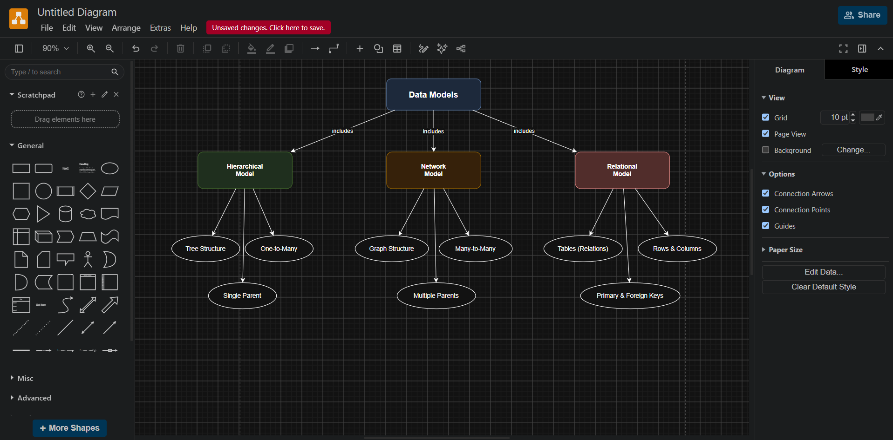
Hierarchical, Network and Relational Data Models
Hierarchical Model
- Tree structure.
- One parent per child.
- Fast retrieval.
- Used in file systems.
Network Model
- Graph structure.
- Multiple parent records.
- Flexible.
- Used in telecommunications.
Relational Model
- Organizes data into tables.
- Uses rows and columns.
- Supports SQL.
- Most widely used today.
Comparison Table
Feature | Hierarchical | Network | Relational
Structure | Tree | Graph | Tables
Parents | One | Many | Relations
Flexibility | Low | Medium | High
SQL Support | No | No | Yes

Question 6
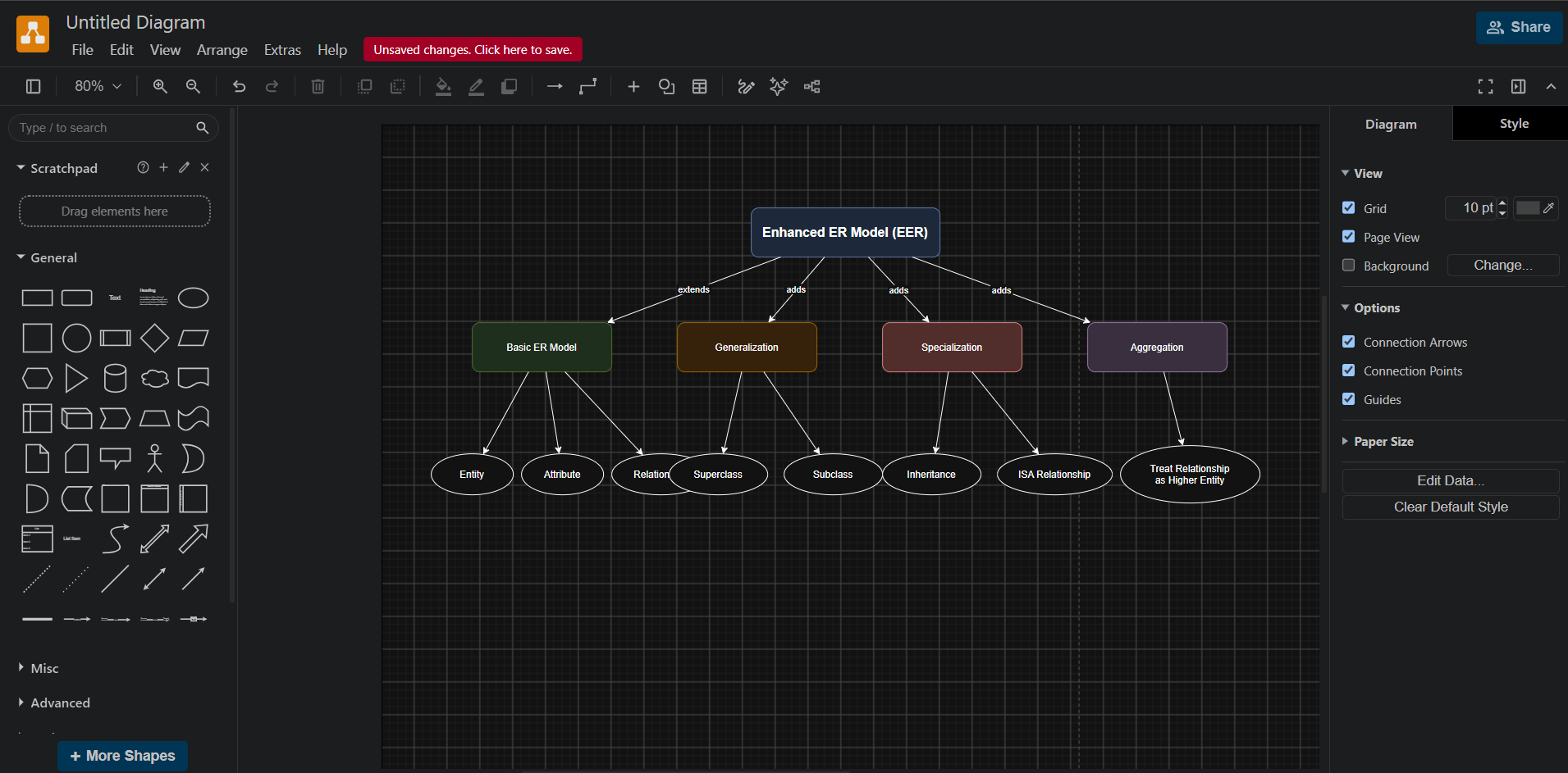
Enhanced ER (EER) Model
Explanation
The EER model extends the ER model with advanced concepts.
Generalization
Combines lower-level entities into one superclass.
Specialization
Divides a superclass into subclasses.
Aggregation
Treats a relationship as a higher-level entity.
Advantages
- Better modeling.
- Represents inheritance.
- Handles complex applications.
Question 7
DBMS Software Architecture
Explanation
The architecture shows how a user request is processed.
- User submits an SQL query.
- Query Processor checks the syntax.
- Query Optimizer selects the best execution plan.
- Storage Manager accesses the database.
- Data is retrieved.
- Results are returned to the user.
Advantages
- Fast query execution.
- Efficient storage.
- Improved performance.
Question 8
Data Models and Real-World Applications
Hierarchical Model
Applications:
- Organization charts
- File systems
- XML documents
Network Model
Applications:
- Airline reservation
- Social networks
- Telecommunications
Relational Model
Applications:
- Banking systems
- Hospital management
- College management
- E-commerce websites
Suitability
Each model is suitable based on the complexity and relationships among data.
Question 9
Schema, Instance and Data Independence
Explanation
Schema
Defines the database structure.
Instance
Represents current database contents.
Logical Data Independence
Allows changes in logical design without affecting user views.
Physical Data Independence
Allows changes in storage without affecting logical design.
Importance
- Easy maintenance.
- Scalability.
- Better performance.
Question 10
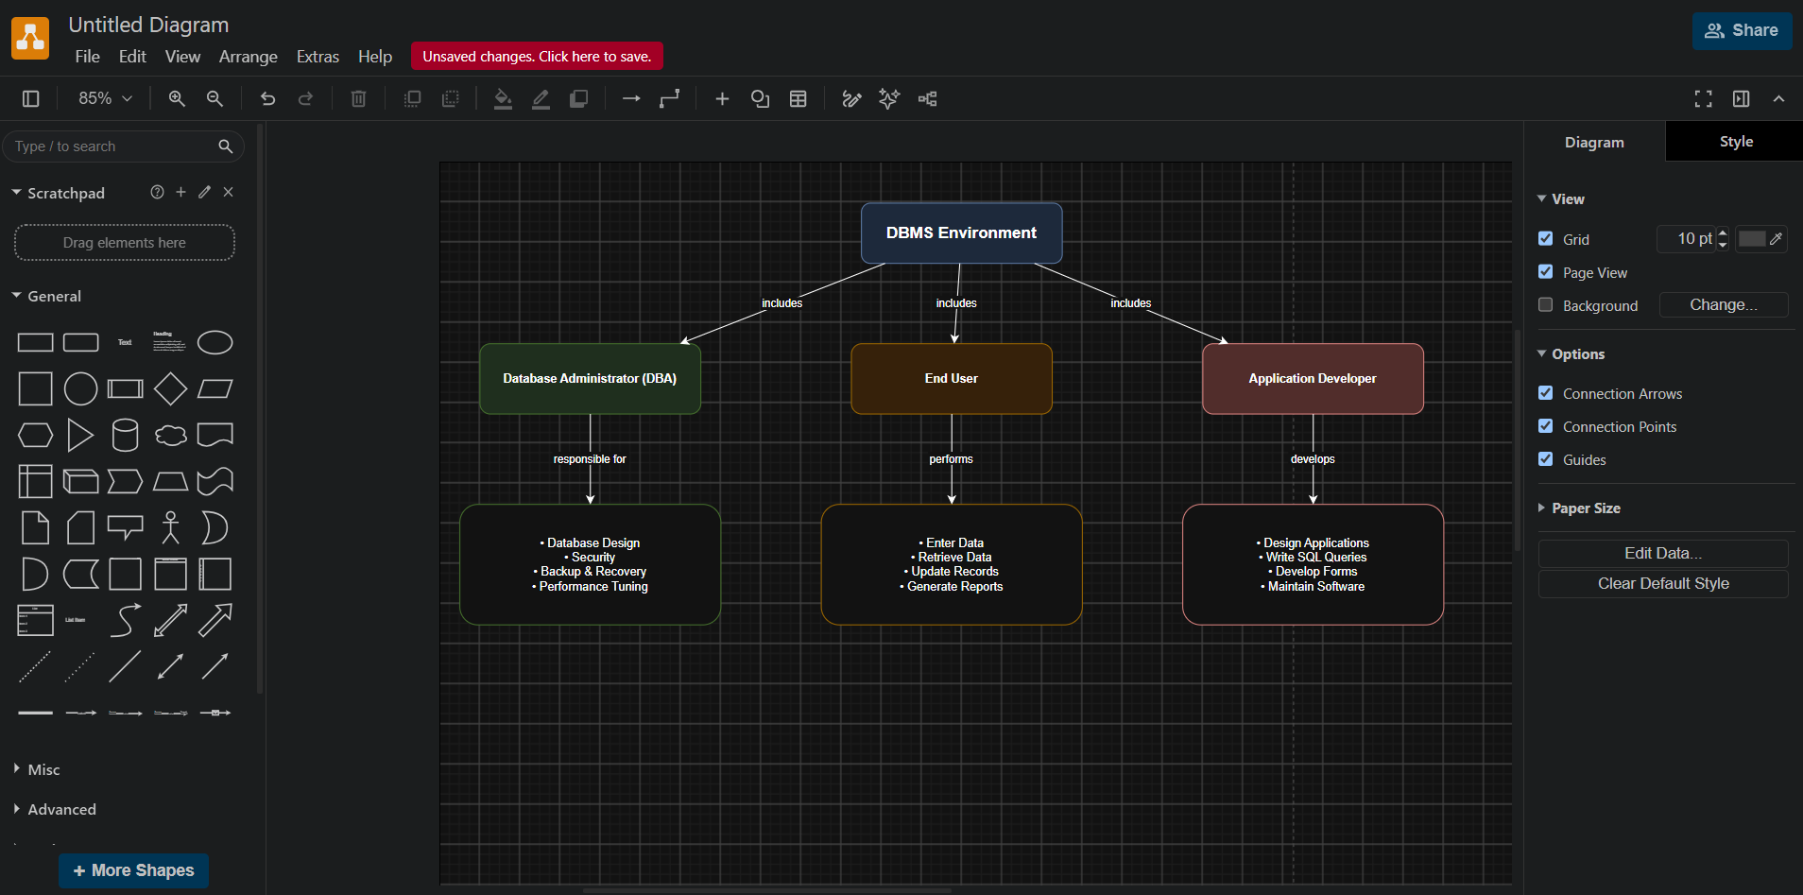
Roles and Responsibilities in DBMS Environment
DBA (Database Administrator)
- Creates databases.
- Controls security.
- Performs backup and recovery.
- Optimizes performance.
- Manages users.
End User
- Uses applications.
- Retrieves data.
- Updates records.
- Generates reports.
Application Developer
- Develops database applications.
- Writes SQL queries.
- Designs forms and reports.
- Tests and maintains software.
Conclusion
The DBA, end user, and application developer work together to ensure that the database system is secure, efficient, and meets organizational requirements.

